**Assignment 16.6**

**1. Write a map reduce program to join the below given two datasets using Reducer side join.**

**DRIVER:**

Used multiple input to get multiple inputs

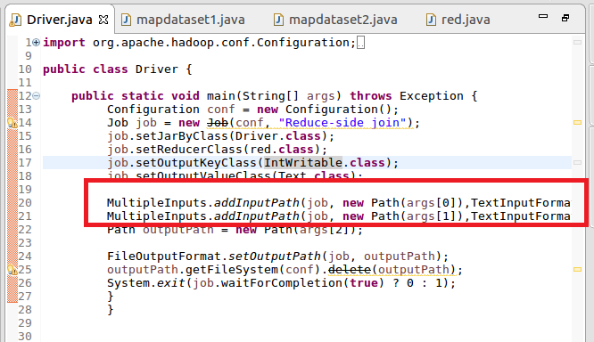

**MAPPER1:**

Sent Id as key and value as value as I want simple join of datasets which I will join in reducer

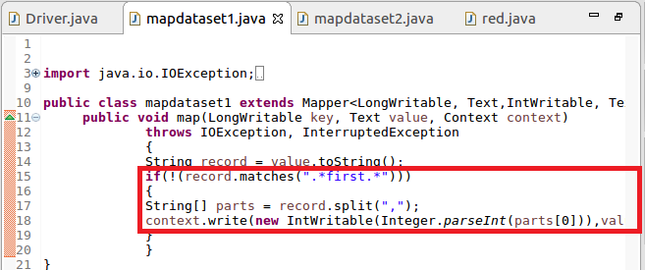

**MAPPER2:**

Sent Id as key and value as value as I want simple join of datasets which I will join in reducer

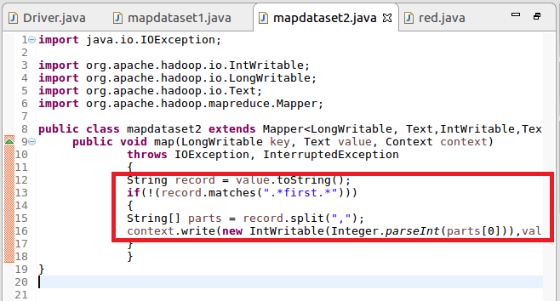

**REDUCER:**

Joined both values and separated it by comma

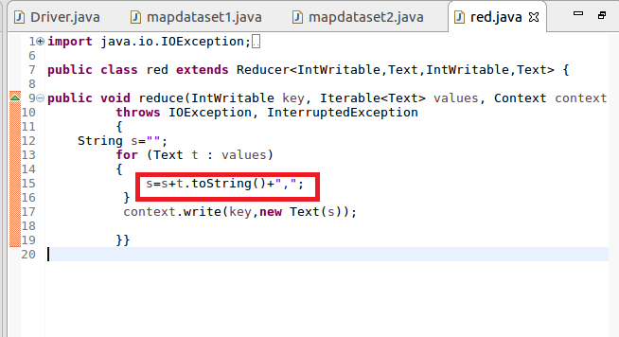

**OUTPUT: ATTACHED (PART-R-0000)**